*Chapter 16, Problem 61.

Find the voltage v_{o}(t) in the circuit of Fig. 16.84 by means of the Laplace transform.

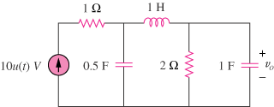

10u(t) V

+
−

Figure 16.84
For Prob. 16.61.

